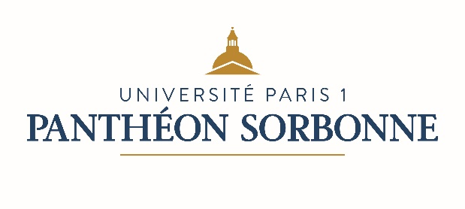

Fact Sheet for Erasmus and International Exchange students
Academic year 2020/2021
International Relations Department
Université Paris 1 Panthéon-Sorbonne
Erasmus Code – EUC Number : FPARIS001
Address: Maison Internationale, 58 boulevard Arago, 75013 Paris, FRANCE
Opening hours: Monday 2pm-5pm / Tuesday 9.30am-12.30pm /Wednesday 9.30am-12.30pm / Thursday 2pm-5pm / Friday 9.30am-12.30pm
Telephone: 00 33 (0) 1 44 07 75 37 / Email: international-contact@univ-paris1.fr
Website: https://www.pantheonsorbonne.fr/

Mobility Office Contacts
Sonia Miranda-Pignal  Head of Mobility Office  + 33 (0)1 44 07 76 71  mobiliteri@univ-paris1.fr | Matthieu Hulbert  Incoming Erasmus / Non-Erasmus exchanges  + 33 (0)1 44 07 76 75  incoming-exchange@univ-paris1.fr
Cécile Lafani  International Credit Mobility  + 33 (0)1 44 07 81 29  mic@univ-paris1.fr | Swan Ming Tun  Choose France Coordinator (Accomodation)  + 33 (0)1 44 07 85 29  international-housing@univ-paris1.fr
Gabriella Torino  Outgoing Mobility World  + 33 (0)1 44 07 76 77  outgoingWorld@univ-paris1.fr | Christelle  Outgoing Mobility ERASMUS  + 33 (0)1 44 07 76 73  outgoingEurope@univ-paris1.fr

Academic Calendar
1st semester: Mid-September to mid-January
2nd semester: Mid-January to end of April

Examination periods
1st semester: First 3-weeks of January
2nd semester: 2nd – 3rd weeks of May
(re-sits, if any: mid to end of June)

Nomination and Application Procedure
Nomination deadlines:
1st semester: May 15th 2020
2nd semester: October 15th 2020

Application deadlines:
1st semester: May 30th 2020
2nd semester: October 30th 2020

Email for nominations: incoming-exchange@univ-paris1.fr

After nomination students will receive the application procedure. They will be asked to fill in the online application form and attach the following documents:
- Copy of a valid passport
- A certificate of French language proficiency (Equivalent of B2 for Undergraduate programmes, and C1 for Master programmes).
- Learning agreement (list of courses signed by the exchange coordinator of home university).
- Student Transcript or record for all previous years of higher education translated in French or English.
- A Curriculum Vitae in French
- A letter of motivation letter in French
- A letter of recommendation from faculty members in French or English language.

Following the nomination deadline and after submitting all of the documents students will receive an admission letter.
Exchange related information
Integration week for incoming students  Languages courses available to international students  Website for incoming students  Accommodation | One week before the beginning of the semester  http://www.pantheonsorbonne.fr/en/ufr/ddl/  http://www.pantheonsorbonne.fr/international/etudiants-etrangers/candidature-en-echange-licence-master/  https://www.pantheonsorbonne.fr/international/foreign-students/accommodation/
Additional useful information
Catalogue of courses available for exchange students: https://www.pantheonsorbonne.fr/international/foreign-students/exchange-student-application-bachelor-master/liste-des-cours-ouverts-aux-etudiants-en-echange/
Website : www.univ-paris1.fr

