**DO GENDERED LANGUAGES FAIL WOMEN IN MATH?  
  
Tamar Kricheli-Katz* and Tali Regev\*\***

**Classifications: Social Science/Social Science**

­­

*Corresponding author. Assistant Professor, Tel Aviv University Faculty of Law. [tamarkk@post.tau.ac.il](mailto:tamarkk@post.tau.ac.il)

** Assistant Professor, Interdisciplinary Center Herzliya, School of Economics. [tregev@idc.ac.il](mailto:tregev@idc.ac.il)

**Abstract**:

Does addressing both women and men in the masculine - a prominent grammatical practice in gendered languages - affect people’s performances in math and reading comprehension?

Using a large random representative sample of the native Hebrew speaking adult population in Israel, we show that when addressed in the feminine, women meaningfully improve their performance in math and reading comprehension. In fact, when women are addressed in the feminine and men in the masculine, the performance gap between women and men is reduced by a third in math and by more than half in reading comprehension, compared to when both women and men are addressed in the masculine. These effects are stronger among participants who acquired the Hebrew language early in childhood rather than later in life. The effects of addressing men in the feminine on their performance in math and reading comprehension are negative, but only marginally significant. We also show that when women are addressed in the feminine, their efforts – in terms of time spent on the test – improve. Women also report that they love science more when addressed in the feminine. Finally, when addressed in the feminine, both women and men express less explicit stereotypes about gender and science.

**Significance**:

This paper illustrates the powerful role of language in perpetuating unequal realities for women and men. Studies have shown that gendered languages activate stereotypes and cultural beliefs about women and men. This paper is the first to demonstrate the effects of gendered languages on the performance of women and men in math and reading comprehension. Although we directly explore the effects of using masculine and feminine generics, the results of our study are relevant to all language, even those in which masculine generics are only rarely used.

**DO GENDERED LANGUAGES FAIL WOMEN IN MATH?**

Does the prominent grammatical practice in gendered languages of addressing both women and men in the masculine affect people’s performances in math and reading comprehension? Would the performance of women in math and reading comprehension improve if they were addressed in the feminine?

Languages vary by their usage of grammatical gender. In gendered languages like French, Spanish, German, and Hebrew, parts of speech – pronouns, nouns, adjectives, and verbs – all have feminine and masculine forms. In addition, in such languages, forms of speech that refer to one gender only (like the words “waiter” and “waitress” in English) are used more frequently than they are in gender-neutral languages. Generic use of the masculine form for both females and males is more prominent in gendered languages than in gender-neutral ones (1, 2).

In this study, we test for the effects of the prominent grammatical practice of using the masculine form as generically applicable to both women and men on the general population’s math and reading comprehension performance. We use a large random representative sample of the Hebrew-speaking adult population in Israel. Hebrew is a gendered language in which the grammatical rule is to use the masculine form of the language as generic for both females and males (3). In fact, when addressing a group that consists of more than one man (regardless of the number of women in the group), the entire group is addressed in the masculine. In the experiment, we let participants - women and men - take SAT-type math or reading comprehension tests while addressed either in the feminine or in the masculine form. We then asked them to complete an explicit gender bias questionnaire and to report their attitudes toward the sciences and the liberal arts. Because the sample for the experiment was both representative and uniquely large (N=1,954), this study offers both the **internal validity that characterizes experiments conducted in controlled settings and the external validity that characterizes studies of large random samples of the population.**

We find that when addressed in the feminine, women meaningfully improve their performance in math and reading comprehension. In fact, when women are addressed in the feminine and men in the masculine, the performance gap between women and men is reduced by a third in math and by more than half in reading comprehension, compared to when both women and men are addressed in the masculine. These effects are stronger among participants who acquired the Hebrew language early in childhood rather than later in life. The effects of addressing men in the feminine on their performance in math and reading comprehension is negative, but only marginally significant. We also show that when women are addressed in the feminine, their efforts – in terms of time spent on the test – improve. Women also report that they love science more when addressed in the feminine. Finally, when addressed in the feminine, both women and men express less explicit stereotypes about gender and science.

Languages reflect and perpetuate the prominent social distinctions and the stereotypes and cultural schemas associated with them – like the distinctions, schemas, and stereotypes associated with sex and gender. Therefore, languages distinguish between sex and gender categories, signal them, and reflect the common cultural beliefs about who women and men are and should be (4, 5, 1, 2). Research suggests that gendered languages are associated with gender inequality and that addressing people in languages with grammatical gender affects their attitudes, perceptions, and motivations. One study showed that the countries in which gendered languages are spoken tend to be associated with greater sex inequality than are countries whose languages feature gender-neutral grammatical systems (6).  In another experimental study, answering a survey about sexist attitudes in a language with grammatical gender (French or Spanish) was found to increase the reported sexist attitudes, compared to answering the same survey in English (7). In a related experimental study, addressing women in the masculine in an academic motivation questionnaire generated lower reports of task value and intrinsic goal orientation compared with addressing women in the gender-neutral form of the language (8). Nonetheless, the literature has not yet fully addressed the effects of gendered languages on women and men’s academic performance.

Why would addressing women and men in the feminine (or in the masculine) forms affect their performance?

First, stereotypes and cultural beliefs about women’s competence and ability in math and science are easily activated; once activated, they may affect the quality of women’s performance. In our society, men are perceived to be better than women in math and science, although the evidence that supports these perceptions is relatively weak (9, 10, 11). These stereotypes and cultural beliefs affect girls and women’s willingness to attribute their success to their abilities rather than to their effort, as well as their persistence when faced with challenges (9). Moreover, stereotypes and cultural beliefs about women’s lower ability in math and science affect women’s actual performance. Studies have shown that when women are exposed to stereotypes about their inferiority in math, for example, they underperform on math tests compared to when such stereotypes are not activated (12). The tendency to preform less well when stereotypes are salient probably relates to the anxiety and distraction generated by the knowledge that people’s expectations of one’s performance are low, to the reduction of one’s own performance expectations, and to the resultant reduction in effort .The effects of stereotypes about women and math on women’s performance are so powerful that merely asking test-takers to indicate their gender prior to taking a math test negatively affects women’s performance (13).

Addressing women and men in the feminine (or in the masculine) forms may affect their performance also because their sense of belonging may be activated. Women addressed in the feminine form may more easily view themselves as the prototypical test taker than they would be when addressed in the masculine. These perceptions of belonging may lead women to believe in their ability to succeed and therefore to increase their effort and concentration and improve their performance. In one related study, job advertisements were constructed to include either more masculine or more feminine wordings in the job description and in the required characteristics of applicants (words such as *leader*, *competitive*, and *dominant,* versus words such as *supportive*, *understanding*, and *interpersonal,* respectively). When advertisements were constructed to be more masculine, participants perceived the positions to be occupied more with men than with women. Moreover, women participants found these jobs less appealing and reported feeling less likely to belong to them (14).Hence, we hypothesized that both the sense of belonging and the stereotypes and cultural beliefs about women and men embodied in the language affect women and men’s actual performance. Addressing women in the feminine would improve their performance in math and reading comprehension, reduce their gender biases, and increase their reported love for science. Because stereotypes about men’s ability and competence are highly prominent in our society, we predicted that addressing men in the feminine form would result in only a minor (if any) effect on men’s performance in math and reading comprehension and on their love for science. We expected men’s gender biases to be reduced when they are addressed in the feminine.

**Methods**

We used a large, random, probability-based sample of the Israeli Hebrew-speaking population to test the effects of addressing women and men in the feminine and in the masculine. In an experiment, participants were asked to take either an SAT-type math test or an SAT-type reading comprehension test, with six questions in each. The experiment consisted of four experimental conditions (2 [addressed in the feminine/masculine]*2 [math/reading comprehension]).

Questions were taken from previous real Psychometric Entrance Exams, published in the official website of the Israeli National Center for Testing and Evaluation.[1] Questions for the math test were taken from the qualitative reasoning sections of the psychometric exams. These questions are designed to assess the ability of participants to use numbers and mathematical concepts for solving quantitative problems. Questions for the reading comprehension tests were taken from the verbal reasoning sections of the psychometric exams. Such questions are designed to assess the ability to analyze and understand complex passages. Throughout the tests, both female and male participants were addressed either in the feminine or in the masculine forms. Unlike in the actual psychometric exam, we gave no time limitations for the math and reading comprehension tests. Upon completion, participants were asked to fill out an implicit association test (15),[2] followed by an explicit bias questionnaire addressing their attitudes and beliefs about the associations of women and men with the sciences and the liberal arts. Finally, participants were asked to report their own attitudes toward science.

The sample for the experiment was a large, random, representative sample of the Israeli Hebrew speaking adult (18+) population in Israel. The data were collected by *Dialogue,* a survey company specializing in Internet-based surveys using a nationally representative web panel. From this pool of participants, panel members are randomly selected to participate in different studies that the company conducts. For the purpose of this study, only Hebrew-speaking adults were randomly selected. The initial sample for the study included 1,954 participants that were randomly assigned to one of the four experimental conditions. Out of the initial sample, 481 took a reading comprehension test and were addressed in the masculine, 490 took a math test and were addressed in the masculine, 510 took a reading comprehension test and were addressed in the feminine, and 473 took a math test and were addressed in the masculine.[3]

Of the 1,954 participants, 17% were born outside of Israel. We included them in the sample because many of them have spoken Hebrew from early childhood. In our analysis, we utilized their age at immigration to Israel as a proxy for language proficiency (16). We hypothesized that the effect of feminine generics weakens as participants’ age at immigration to Israel increases.

**Results**

*Descriptive Statistics*

In Table 1, we present the descriptive statistics for the variables we use in the analysis. On average, participants scored 63% on the math test, with an average time of 1.1 minutes per question. The average score on the reading comprehension test was 50%, with an average time of 1.77 minutes per question. Whereas all participants completed the math or the reading comprehension test, only 77% of them completed the full questionnaire, which included an Implicit Association Test and the attitudes and explicit biases survey. We therefore have attitude and bias measurements only for a selected sample of those who stayed until the end of the experiment. Whenever we used these outcomes, we tested whether the selection of participants results in biased estimates of our main coefficients.

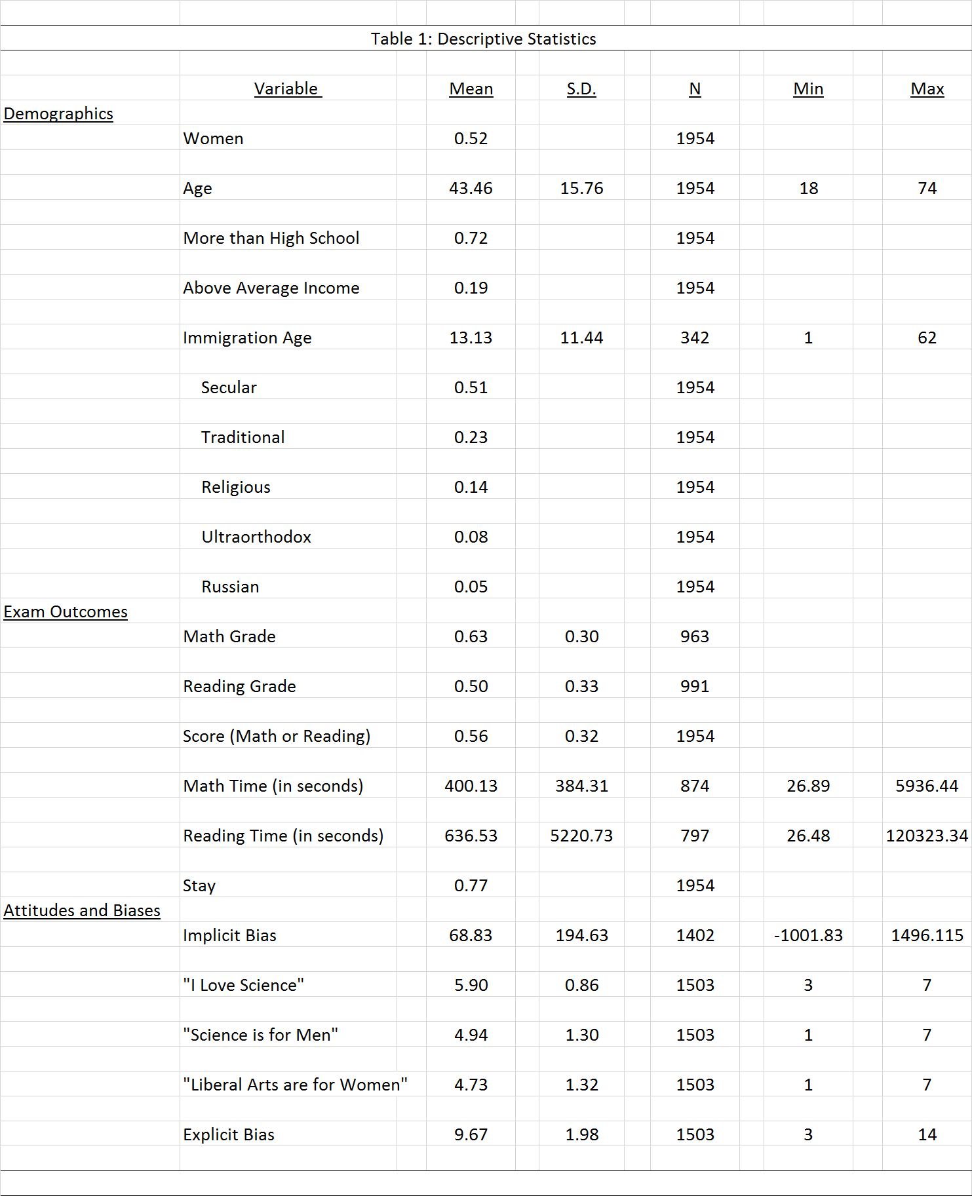

Variables capturing attitudes and biases were constructed from participants' responses to the survey questionnaire presented in the last section of the experiment. The variable "I Love Science" captures participants' responses to a question that asked them to rate their attitude towards science (ranging from 1 = strongly dislike to 7 = strongly like). Participants were also asked to rate how strongly they associate the liberal arts and sciences with women and men (on scales of 1 to 7). The answers to these questions were transformed to the variables "Liberal Arts are for Women" and "Science is for Men." The explicit bias variable is the sum of the two previous questions. In Table A1, we present the results of a balancing test, by experimental condition. In order to make sure that differences in the demographic characteristics of participants do not bias the results, we supplement our analyses with models controlling for the demographic characteristics of participants.

*Feminine Generics and Performance*

Figure 1 graphically presents participants' mean grades in math and reading comprehension by gender and experimental condition. It can be seen that on both tests, on average, women receive lower grades than men do. Addressing participants in the feminine form increases women's grades and decreases men's.

**Figure 1: Mean Grades in Math and Reading Comprehension, by Gendered Address**



To assess the statistical significance of our results, we ran OLS regression models predicting the effect of addressing participants in the feminine form on their test performance. Results are presented in Table 2. In all the models, the sample includes only native Hebrew speakers who were born in Israel, unless specified otherwise (N=1,612).

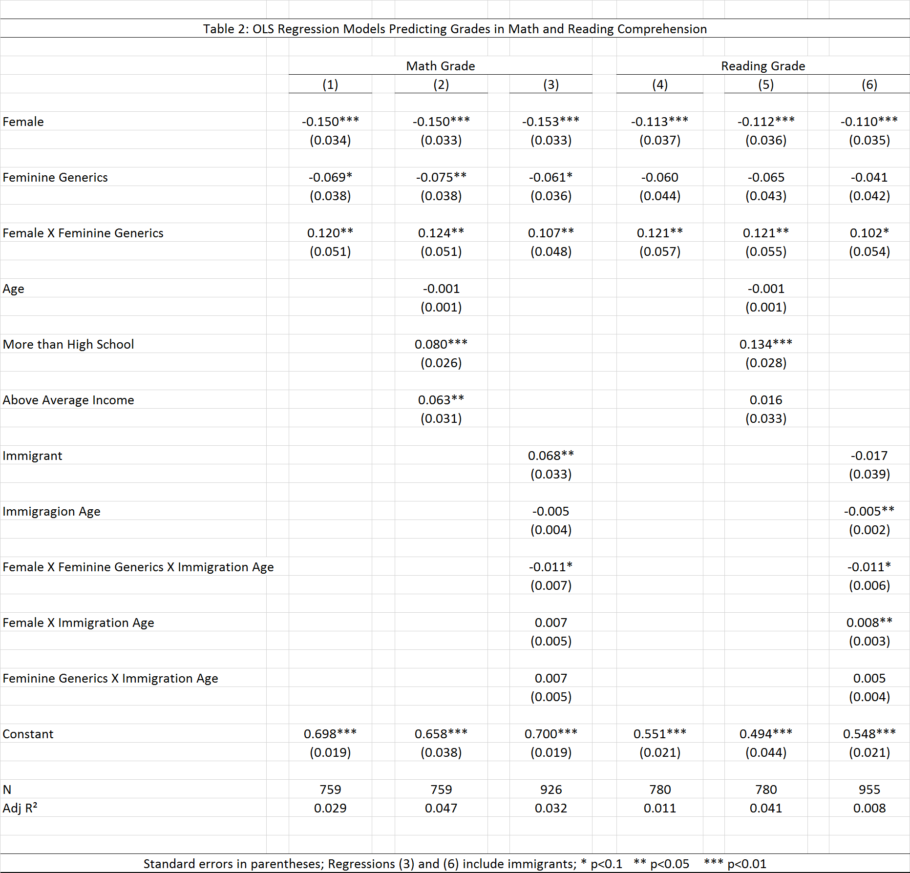

For math, we find that when addressed in the masculine, women receive grades that are lower by 15 percentage points than the grades men receive (Model 1; p<0.01, N=759). When addressed in the feminine, women's math grades are higher by 5 percentage points relative to when addressed in the masculine. However, when addressed in the feminine, men's grade are lower by 7 percentage points than when addressed in the masculine (Model 1; p <0.1, N=759). In fact, when both women and men are addressed in the feminine, the gender gap in math becomes statistically insignificant. When women are addressed in the feminine and men in the masculine, women receive, on average, grades that are lower only by 10 percentage points than men's (Model 1; p<0.001, N=759). When the demographic characteristics of participants are included, the effects remain relatively similar (Model 2). Model 3 includes immigrants and controls for their immigration age. We find that the effect of language on immigrants is smaller. Being a year older when immigrating decreases the effect of feminine generics on women by 1 percentage point (p<0.1, N=926).

In the reading comprehension test, when addressed in the masculine, women receive grades that are lower by 11 percentage points than the grades received by men (model 4; p<0.01, N=780). When addressed in the feminine, women's grades are 6 percentage points higher than the grades women receive when they are addressed in the masculine (p<0.1, N=780). When both women and men are addressed in the feminine, the gender gap in reading becomes statistically insignificant. When women are addressed in the feminine and men in the masculine, on average, women receive grades that are lower only by 5 percentage points than men's (Model 1; p<0.1, N=780). When the demographic characteristics of participants are included, the effects remain relatively similar (Model 2). Model 3 includes immigrants and controls for their age at immigration. Finally, similar to the case with math, as the age of immigration rises by each additional year, the positive effect of addressing women in the feminine declines by 1 percentage point (p<0.1, N=955).

*Attitudes and Biases*

When addressed in the feminine form, women report loving science more than when addressed in the masculine form (Table 3). In an OLS regression model predicting "I Love Science," women's love for science increases by 0.12 when addressed in the masculine (Model 1; p<0.1, N=604; an increase of 0.14 standard deviations). The effects for men are insignificant (Model 2). These results remain practically unchanged when demographic characteristics of participants are included in the regressions (Models 4 and 5).

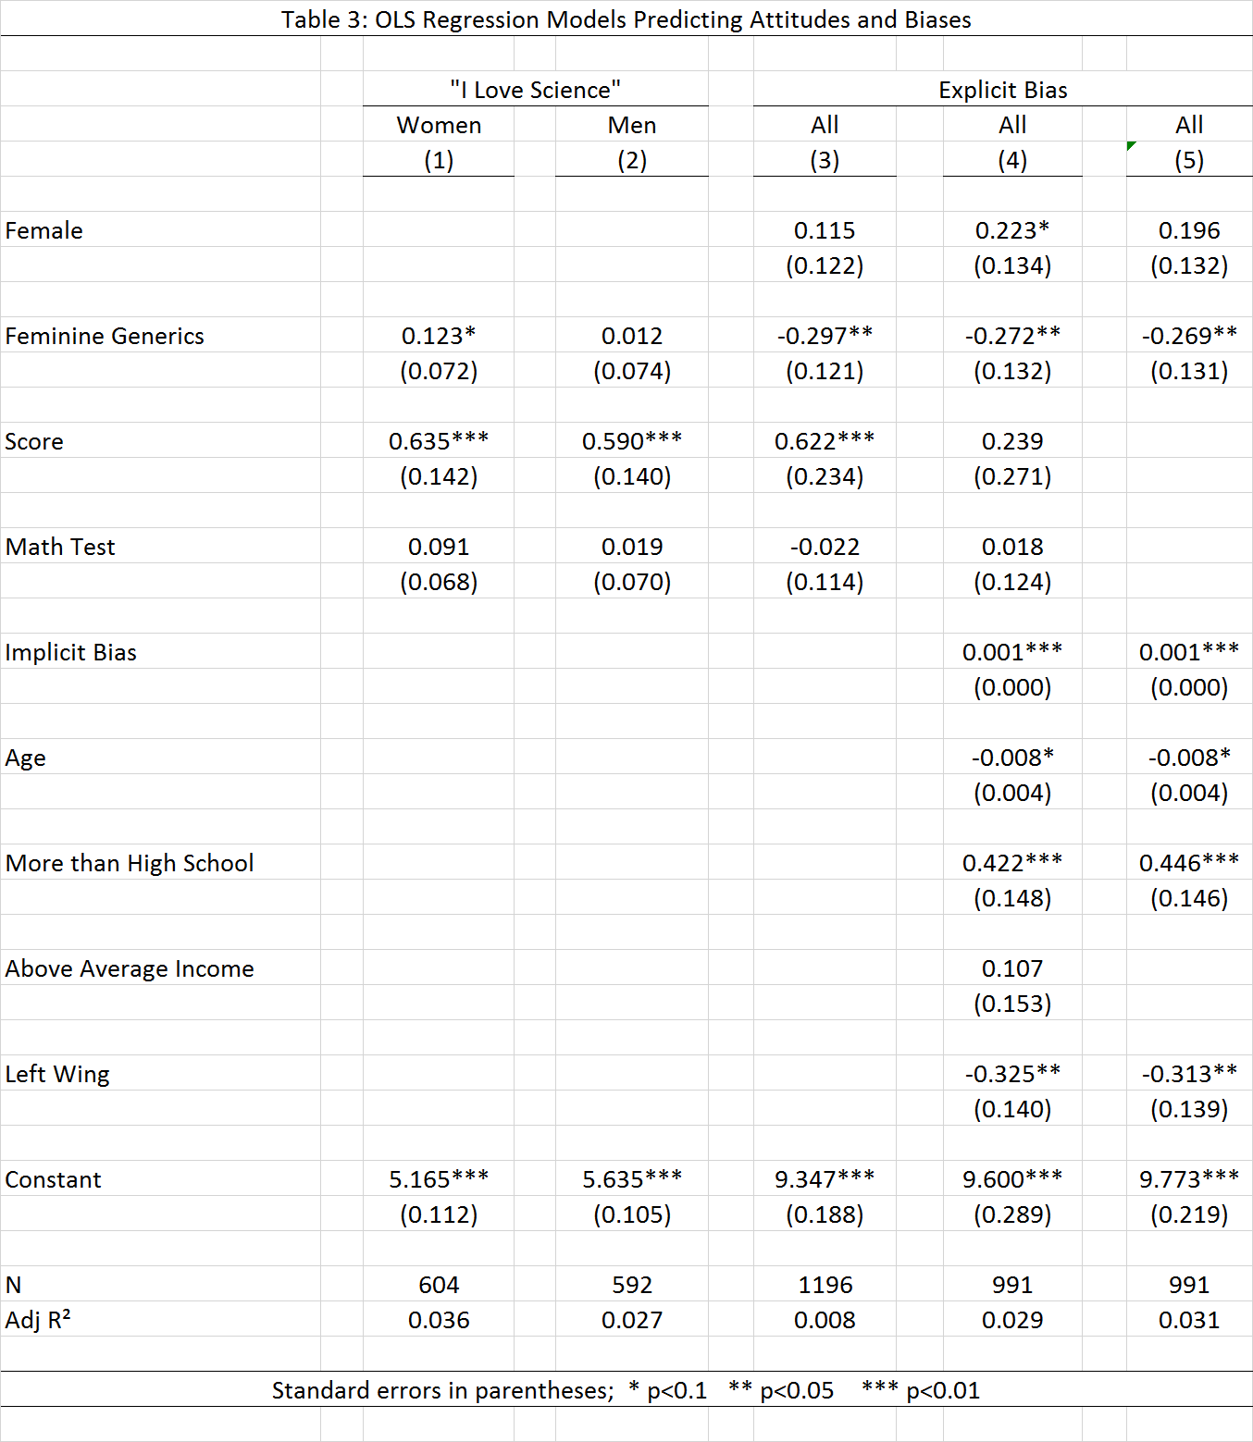 Addressing participants in the feminine reduces their explicit biases, as professed by the explicit association of women with liberal arts and of men with science. When addressed in the feminine, explicit biases of both women and men are smaller by 0.30 (a decrease of 0.15 standard deviations; Model 3; p<0.05, N=1196).

For those participants who did not finish the experiment, measures of attitudes and biases are missing. Nonetheless, the effect of being addressed in the feminine on the tendency to finish the experiment was not statistically significant. Thus, we assume that the effects of being addressed in the feminine on attitudes and biases are not driven by differences in the tendency to finish the experiment and are therefore unbiased.

*Feminine Generics and Effort*

We use the time spent on the math test as a proxy for effort. Indeed, the time spent on the math test correlates with the grade in math (Table 4, Model 3; p<0.01, N=677).[4] In an OLS regression model predicting the time spent on the math test, we found that when addressed in the masculine, women spend on average 112 seconds less on the test than men do (model 1, p<0.05, N=688). When addressed in the feminine, women spend 71 seconds more on the math test than when addressed in the masculine (an increase of 0.3 standard deviations, p<0.01, N=688). On the other hand, when men are addressed in the feminine, they spend 86 second less on the math test compared to when addressed in the masculine (p<0.1, N=688). When the demographic characteristics of participants are included, the effects remain relatively similar (Model 2).

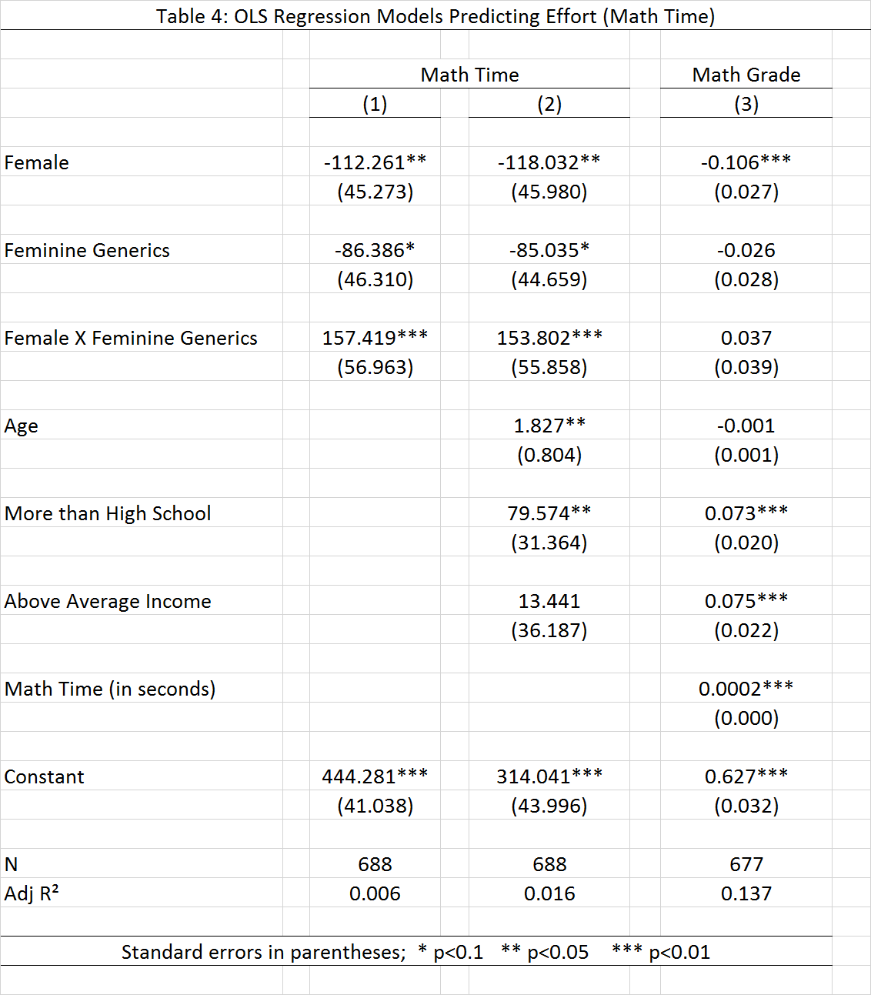

**Discussion**

Our findings suggest that both the sense of belonging and the stereotypes and cultural beliefs about women embodied in gendered languages affect the performances of women and men: we show that when addressed in the feminine, women meaningfully improve their performance in math and reading comprehension. The effects of addressing men in the feminine on their performance in math and reading comprehension is negative, but only marginally significant. We also show that when women are addressed in the feminine, their efforts – in terms of time spent on the test – improve. Women also report that they love science more when they are addressed in the feminine. Finally, when addressed in the feminine, both women and men express less explicit stereotypes about gender and science.

The results of our study demonstrate the powerful role of language in activating stereotypes and cultural beliefs and the powerful role of stereotypes and cultural beliefs in affecting actual performance. Although we directly explore the effects of using masculine and feminine generics in gendered languages, the results of our study are relevant to all language, even those in which masculine generics are only rarely used.

Our study has some policy implications regarding the ways in which women and men ought to be addressed in exams and in other learning environments. Note that participants in the study took the tests at home – individually, not in a classroom. Thus, we may reasonably assume that women participants who were addressed in the feminine did not think that men participants were also addressed in the feminine. We therefore do not know whether the women participants would have felt discomfort had they known that some men were addressed in the feminine, and whether such discomfort would have affected their performance. Note also that the effects of being addressed in the feminine on men are negative, although marginally significant. It follows, therefore, that in order to improve women’s performance, women and men should be granted the right to choose whether they wish to be addressed in the feminine or in the masculine in exams. Because the stereotypes and cultural beliefs embodied in the language may affect women’s learning experiences and not only their performance in exams, the language spoken in classrooms should also be modified to include feminine generics and neutral forms.

Naturally, modifying the languages of exams, and even the language spoken in classrooms, would not altogether eliminate gender gaps in math and reading comprehension performance. Gender inequality is persistent and overdetermined: it is consistently and simultaneously generated and maintained in multiple arenas of life and spanning different levels of analysis (17, 18, 19, 20). Yet, tackling such inequality within each arena or level of analysis is important in generating the possibility for change. The ability to minimize gender gaps in standardized testing results merely by changing the gender of the language used is indicative of the power of language in perpetuating unequal realities.

**References**

(1) Ibrahim, M. H. (1973). Grammatical gender: Its origin and development. The Hague, Netherlands: Mouton.

(2) Stahlberg, D., Braun, F., Irmen, L., & Sczesny, S. (2007). Representation of the sexes in language. In K. Fiedler (Ed.), Social communication: Frontiers of social psychology (pp. 163–187). New York, NY: Psychology Press.

(3) The Academy of the Hebrew Language. (2010). Q&A: Relating both to man and woman. Retrieved from <http://hebrew-academy.huji.ac.il> [in Hebrew].

(4) Wolff, P., & Holmes, K. J. (2011). Linguistic relativity. Wiley Interdisciplinary Reviews: Cognitive Science, 2, 253–265.

(5) Parks, J. B., & Roberton, M. A. (1998). Influence of age, gender, and context on attitudes toward sexist/nonsexist language: Is sport a special case? Sex Roles, 38, 477– 494.

(6) Prewitt-Freilino, J., Caswell, T. A., & Laakso, E. K. (2012). The gendering of language: A comparison of gender equality in countries with gendered, natural gender, and genderless languages. Sex Roles, 66, 268 –281.

(7) Wasserman, B. D., & Weseley, A. J. (2009). ¿Qué? quoi? Do languageswith grammatical gender promote sexist attitudes? Sex Roles, 61, 634 –643.

(8) Vainapel, S., Shamir, O.Y., Tenenbaum, Y., Gilam, G. (2015). The Dark Side of Gendered Language: The Masculine-Generic Form as Cause of Self-Report Bias. Psychological Assessment, 27, 1513–1519.

(9) Correll, Shelley J. 2001. “Gender and the Career Choice Process: The Role of Biased Self-Assessment.” American Journal of Sociology 106:1691–1730.

(10) Hyde, Janet S. 2005. “The Gender Similarities Hypothesis.” American Psychologist 60:581

92.

(11) Nosek, B. A., Banaji, M. R., & Greenwald, A. G. (2002). Math= male, me= female, therefore math≠ me. Journal of personality and social psychology, 83(1), 44.

(12) Spencer, S. J., Steele, C. M., & Quinn, D. M. (1999). Stereotype threat and women’s math performance. Journal of Experimental Social Psychology, 35, 4 –28.

(13) Danaher, K. and Crandall, C. S. (2008), Stereotype Threat in Applied Settings Re-Examined. Journal of Applied Social Psychology, 38: 1639–1655.

(14) Gaucher, Danielle; Friesen, Justin; Kay, Aaron C. (2011). Evidence that gendered wording in job advertisements exists and sustains gender inequality. Journal of Personality and Social Psychology, Vol 101(1), 109-128.

(15) Nosek BA, Greenwald AG and Banaji MR (2005). Understanding and using the Implicit Association Test: II. Method variables and construct validity. Pers Soc Psychol Bul 31:166–180.

(16) Stevens, G. (1999). Age at immigration and second language proficiency among foreign-born adults. Language in Society, 28(4), 555–578.

# (17) Ridgeway, C.L. (2011) Framed by Gender: How Gender Inequality Persists in the Modern World. Oxford University Press.

(18) Ridgeway, C L. and S. J. Correll (2004) Unpacking the Gender System: A Theoretical

Perspective on Cultural Beliefs and Social Relations. Gender and Society, 18:510-31.

(19) Ridgeway, C. L. and L. Smith-Lovin (1999) The Gender System and Interaction. Annual

Review of Sociology, 25:191-216.

(20) Risman, B. J. (1998) Gender Vertigo: American Families in Transition. New Haven, CT:

Yale University Press.

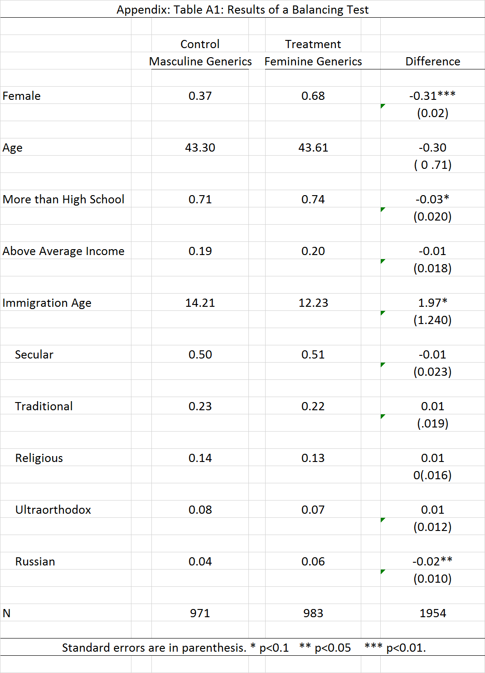

1. The Psychometric Entrance Exam is a tool for predicting academic performance and is used by institutions of higher education in Israel to screen applicants. The test ranks all applicants on a standardized scale. In 2015, 54.6% of the test takers identified as female, 38.5% identified as male, and 6.9% did not report their gender. As in previous years, women’s scores on the 2015 exam were 39 points lower than those of men on average, comprising, a gap of about 0.4 standard deviations (Statistical Report of 2015, the Israeli National Center for Testing and Evaluation).
2. The Gender-Science Implicit Association Test is part of Harvard's implicit project ([https://implicit.harvard.edu/](http://https/implicit.harvard.edu/)); it is a computer-based test that is designed to assess participants' implicit biases about gender and science. It measures the time it takes participants to associate words that represent men and women (e.g., "man," "son," "boy," vs. "woman," "aunt," "wife") to words that represent the sciences and the liberal arts (e.g., "Astronomy," "Math," "Chemistry," vs. "History," "Art," "Music"). The implicit bias score measures the difference between the average time it takes a participant to correctly associate women with the sciences and men with liberal arts (the "hard association") and the average time it takes her to correctly associate women with liberal arts and men with the sciences (the "easy association").
3. The company recruited participants in two waves. First, 1,278 participants were recruited randomly out of the representative pool of members. All men were assigned to one of the two “masculine” conditions and all women to one of the two “feminine” condition. In the second wave, 676 participants were recruited randomly. All women were assigned to one of the two “masculine” conditions and all men to one of the two “feminine” conditions.
4. No such a positive relationship exists between the time spent and the grades received on the reading comprehension test.