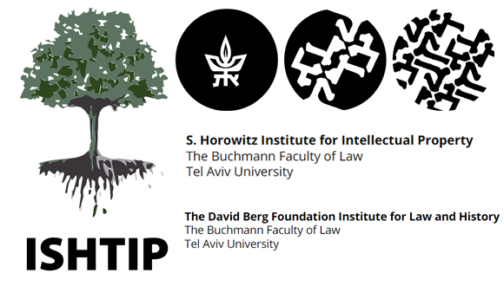
Intellectual Property: Migration
Call for Papers
Faculty of Law, Tel Aviv University
20-21 June 2023
The 14th Annual Workshop of the International Society for the History and Theory of Intellectual Property (ISHTIP) will be hosted by the S. Horowitz Institute for Intellectual Property and the David Berg Institute for Law & History, at the Faculty of Law, Tel Aviv University.
The workshop will be conducted in-person.
ISHTIP @ TAU will highlight the movement of people, practices, and technologies from one place to another, crossing physical borders and metaphysical barriers. We will explore themes related to migration and IP.
Migration may refer to people, e.g., authors and inventors who emigrated to another country – willingly or being forced to leave. Migration may refer to practices, such as business practices and norms of marking one’s products or services. Migration may refer to technologies, crossing borders, meeting different social, cultural, political and legal environments than their cradle. Migration may refer to ideas and legal concepts.
We are particularly interested in the process: How do authors adjust to new cultural, economic and legal environments? Do the incumbent cultural, social and legal systems change as they respond to the migration of the creative people or their imported business practices? How do products and trademarks fit within a new environment? What happens when a foreign entity – being a colonizer, an investor or a consumer – meets and interacts with the locals? How do ideas travel across borders, cultures and across time? We wish to place friction, resistance, change or acceptance under the spotlight. Historical, cultural, economic and legal analyses are welcome.
As always, we are happy to consider any other paper which is within ISHTIP’s scope.
Guidelines for contributors
We welcome papers from all academic disciplines. Papers that address this call from cultural-studies, historical, or theoretical perspectives are particularly welcome, as are contributions from scholars working across disciplines or using alternative methods. Established and junior scholars are encouraged to submit papers.
Proposers should be aware that authors (except for Ph.D. students) do not present their own papers at ISHTIP workshops. Rather, a discussant, often from a discipline other than the home discipline of the author, presents a brief summary and critique of papers to facilitate a more interdisciplinary discussion and build scholarly discourse across disciplines.
To be considered for the workshop, please submit a 300-word abstract of your proposed paper as well as a one-paragraph bio and 2-page CV by 31 January 2023 by email to : shiip@tauex.tau.ac.il
Full working papers are due by 22 May 2023. The papers should not have been previously published.
Important dates
- Submission of proposals: 31 January 2023
- Expected Date for notification of acceptance: 10 March 2023
- Submission of full papers: 22 May 2023
Workshop Organizing Committee: Michael Birnhack (TAU Law), Niva Elkin-Koren (TAU Law)
Academic committee:
Maurizio Borghi, Law, Bournemouth University; Kathy Bowrey, Law, University of New South Wales; Merima Bruncevic, Law, University of Gothenburg; Gabriel Galvez-Behar, History, University of Lille; Eva Hemmungs Wirtén, Social Change and Culture, Linköping University; Claudy Op Den Kamp, Film, Bournemouth University

